PROJECT TESTING PHASE
AI BlogNest API
API Testing • AI Content Generation • Authentication • Blog Management

Project Title:
AI Blog Nest API – An Intelligent Backend for Blog Operations
Team ID : SWTID-2026-4636
Team Size : 4
Team Leader : SAI TEJA SHRI P
Team member :
SAI TEJA SHRI P
YAMINISREE P
HARSHITHA K
ISHWARYALAKSHMI S

1. Testing Overview
The Project Testing Phase verifies that AI BlogNest API works correctly across authentication, AI-powered content generation, blog management, database operations, validation and error handling. Postman is used to send requests and verify JSON responses.

🔐  AUTHENTICATION  JWT + bcrypt | 🤖  AI FEATURES  Generate + Summarize | 📚  BLOG API  Create + CRUD | 🧪  TESTING  Postman

2. API Testing Flow
POSTMAN → EXPRESS REST API → JWT AUTHENTICATION/ AI PROCESSING → MONGODB DATABASE→ JSON RESPONSE

3. Testing Dashboard
Module | Tests | Expected Result | Status
Authentication | 4 | Login & protected routes | PASS
AI Features | 3 | Generate & summarize | PASS
Blog Management | 5 | Create & CRUD | PASS
Validation | 2 | Invalid input handling | PASS
Database | 3 | Store & retrieve data | PASS
4. Postman Testing Evidence
Paste your actual Postman screenshots into the spaces below. The large placeholders are designed to keep screenshots clear and readable.

- • USER REGISTRATION
Registration request, request body and successful response

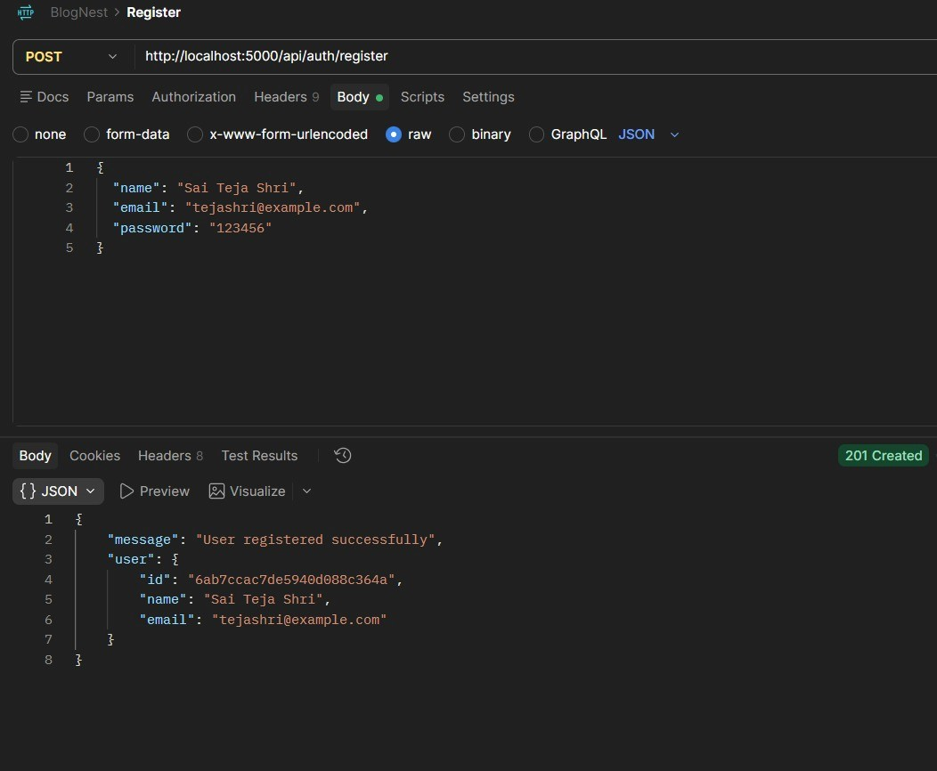

02 • LOGIN
Login request, JWT/session response and status code
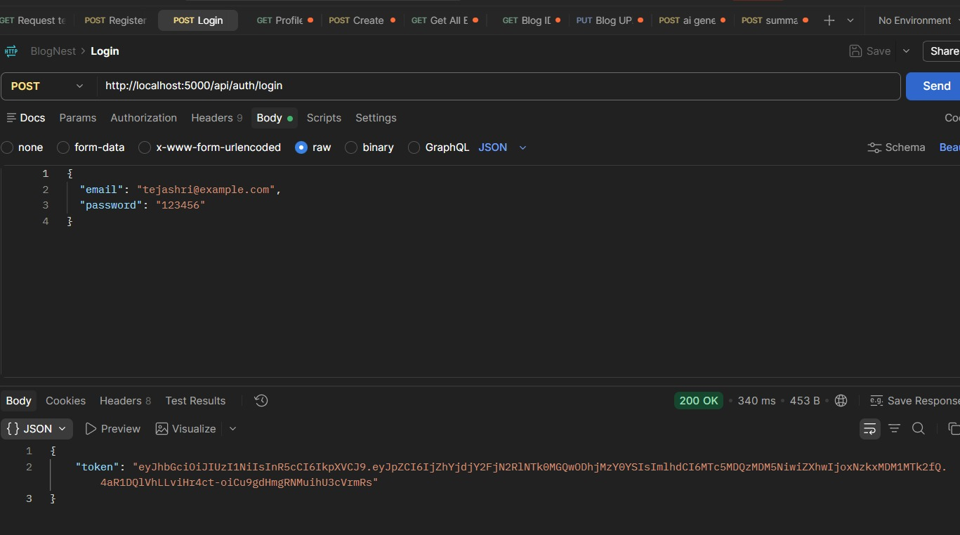

03 • CREATE BLOG
Create-blog request with input data and successful response
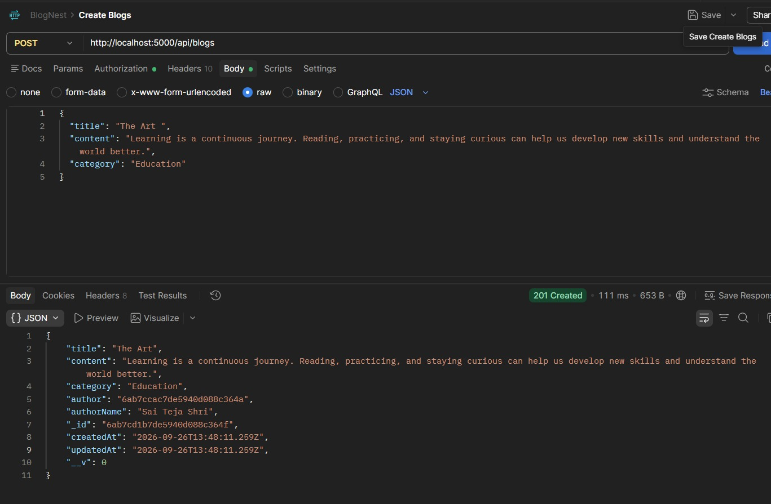

04 • Fetch Blogs  Retrieve all saved blogs  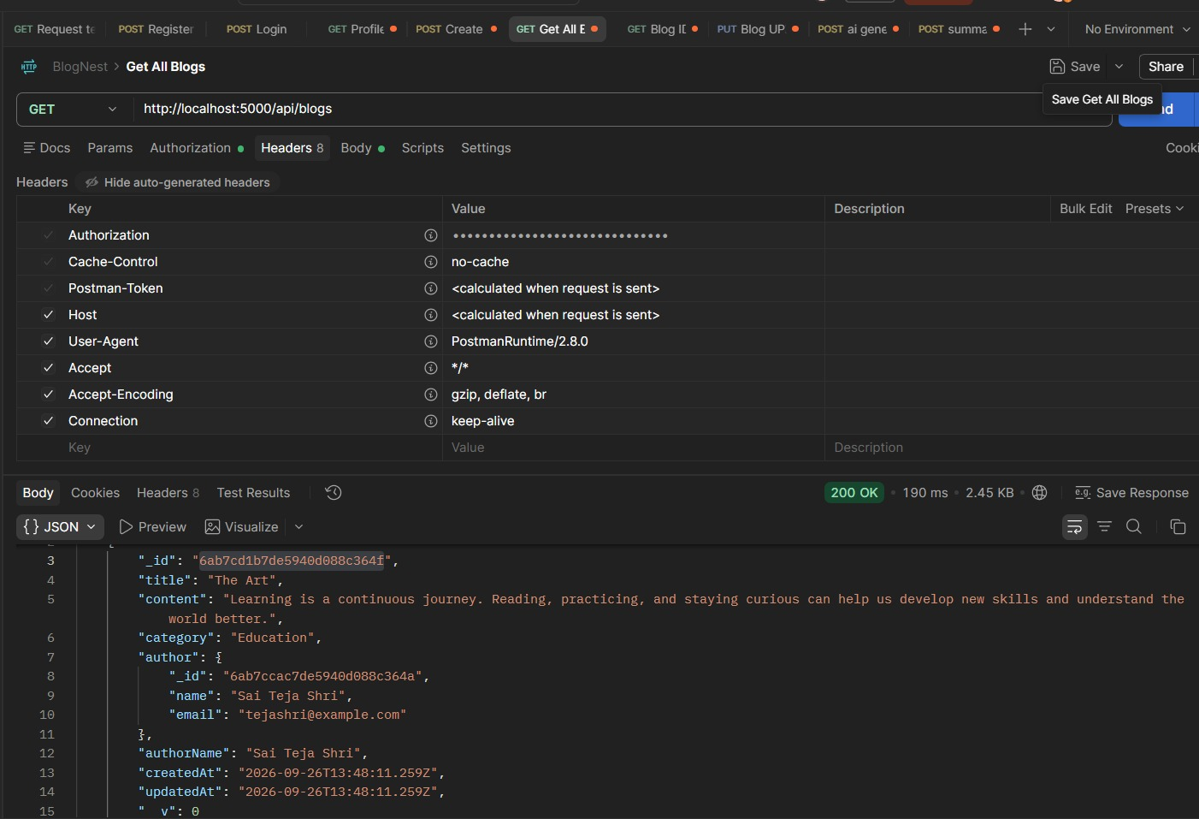 | 04 • AI BLOG GENERATION  Topic/category request and AI-generated blog response

05 • AI BLOG GENERATION
Topic/category request and AI-generated blog response
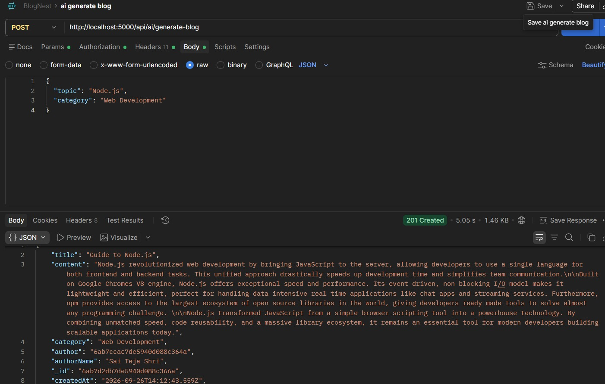

06 • BLOG SUMMARY
Summary request and generated summary response
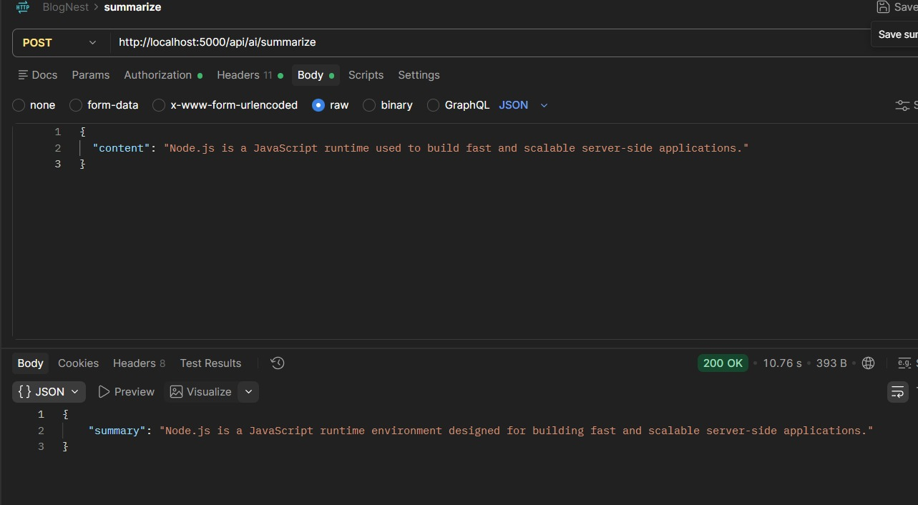

5. Testing Notes
Testing tools: Postman • Node.js + Express.js • MongoDB • JWT + bcrypt • Generative AI API
The screenshots above provide visual evidence of registration, login/session, blog creation, AI blog generation, and blog summarization.

AI Blog Nest API Testing Video: API testing Video

